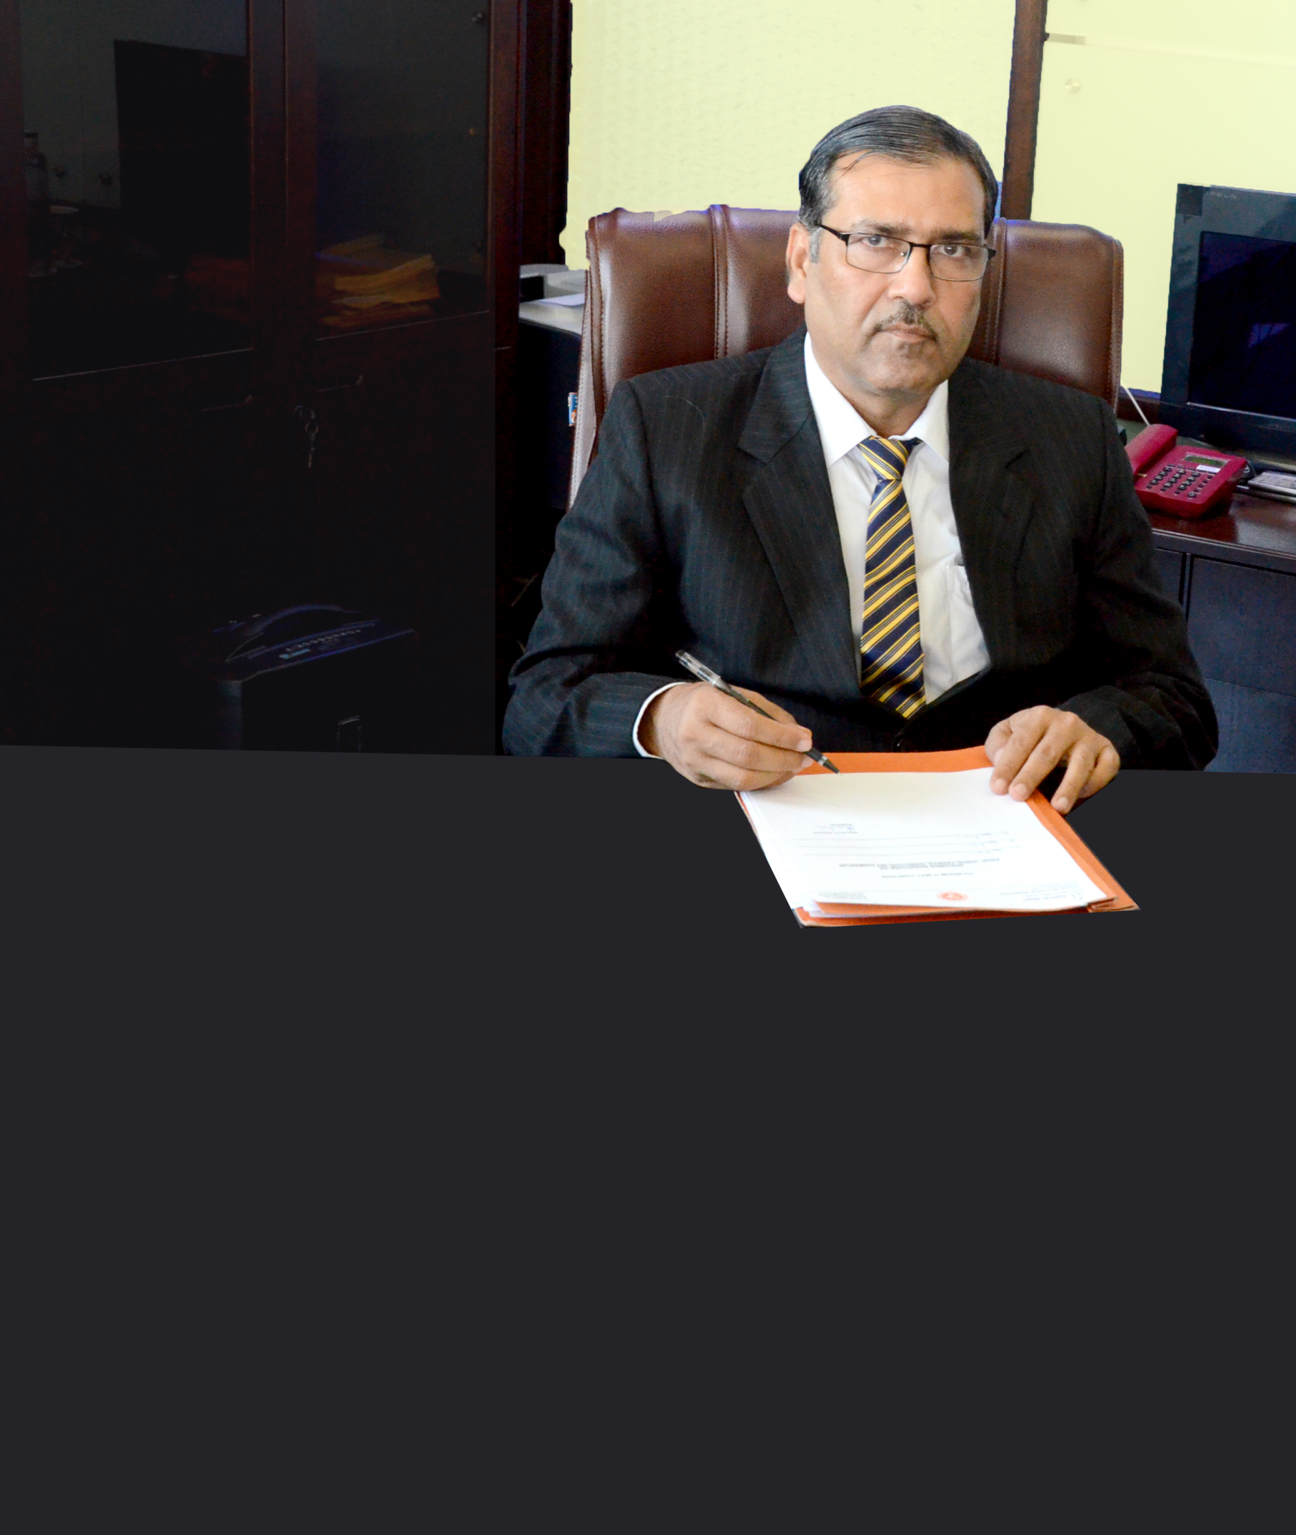

National Institute of Technology Hamirpur is one of the premier engineering institute in the country with the status of “An Institute of National Importance”. It provides world class graduates, post graduates and PhD Research Scholars year after year.

Our students are an integral part of India's growth story. The Nation’s best education system, along with finest facilities has ensured that our students achieve excellence in the chosen fields.

The students of our institute has been making an edible impact on the organizations in which they have been selected. All of our

students are groomed in a manner which give them a perfect combination of technical intellect and social awareness. It foster the spirit of national Integration among the students, a closed interaction with industry and a strong emphasis on basic and applied research. I am certain that our students will find their dream jobs. Equally, I am sure that the organizations will appreciate the association of a students.

I wish each and every students all the best for placement in the academic year 2018-19.

Best Regards,

Prof. Vinod Yadava